Translating Design Into Code
Tyler Daniels
Southern New Hampshire University
CS-560
Professor Palmer
10-18-26

Translating Design Into Code
I started translating the Figma prototype into the Nature Soundscape application by breaking the interface into smaller parts. These included the page heading, subtitle, track list, favorite counter, and playback controls. I used the prototype as a reference for the layout, spacing, colors, and placement of each element. The default application screen shows the resulting structure, with track information on the left and the heart and play buttons aligned on the right. Keeping this arrangement consistent makes the list easy to scan.
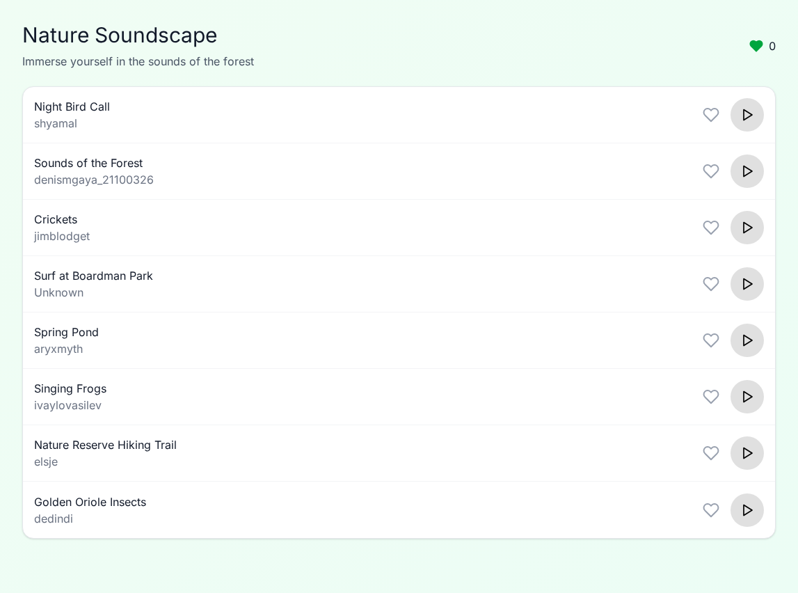
Figure 1. Default application screen before selecting playback or favorites.
I built the application using Vue and separated repeated interface elements into reusable components. The App.vue screenshot shows imports for AudioTrack and HeartIcon, along with the track data and audio-player logic. Instead of writing a separate row for every sound, I used v-for to generate the list from the track data. Each row receives its own playback, loading, and favorite states. The event bindings connect the buttons to the functions that handle playback and favorite changes. This approach helped keep the rows consistent while allowing each track to respond independently.
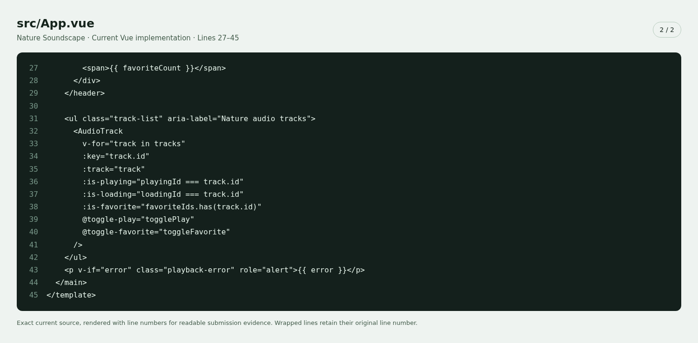
Figure 2. Dynamic track rendering and event bindings in App.vue.
I used reactive state to connect the favorite controls to the total displayed in the header. Selected track IDs are stored in a set, and a computed value calculates the number of favorites. The toggleFavorite function adds or removes an ID when the user selects a heart. This keeps the counter tied to the current selection rather than updating it separately, which reduces the chance of the displayed number becoming inconsistent.
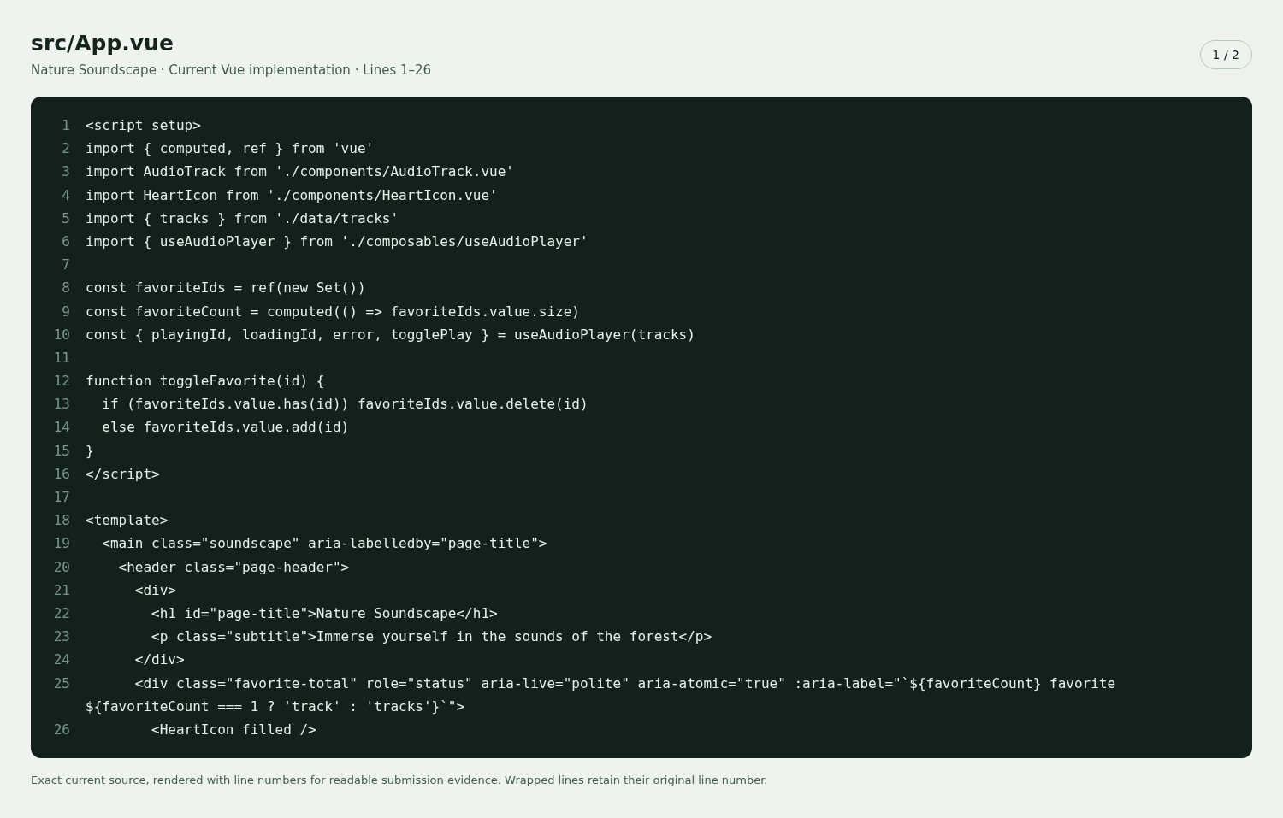
Figure 3. Reactive favorite selection and the computed favorite counter.
For the playback controls, I used conditional rendering to display loading, pause, or play icons according to the track’s state. I also added labels and state attributes so the control communicates its purpose beyond its appearance. The CSS screenshot shows how the active playback button changes to green with a white icon. It also includes consistent button sizes, hover styles, and adjustments for smaller screens. These details helped carry the design into the implementation while accounting for interaction states.
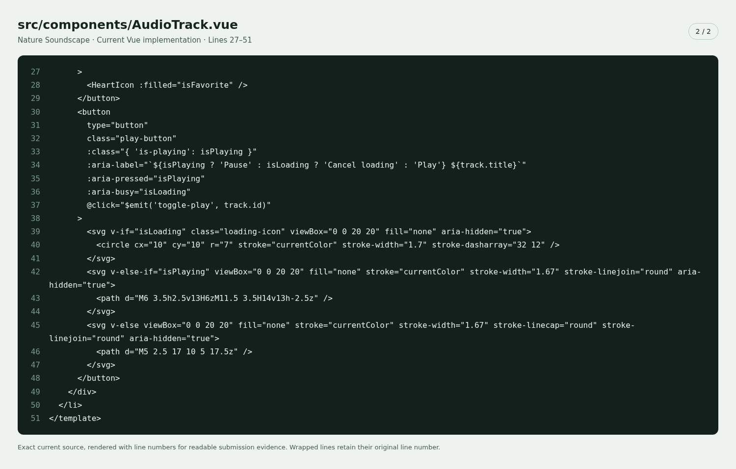
Figure 4. Conditional rendering for playback controls.
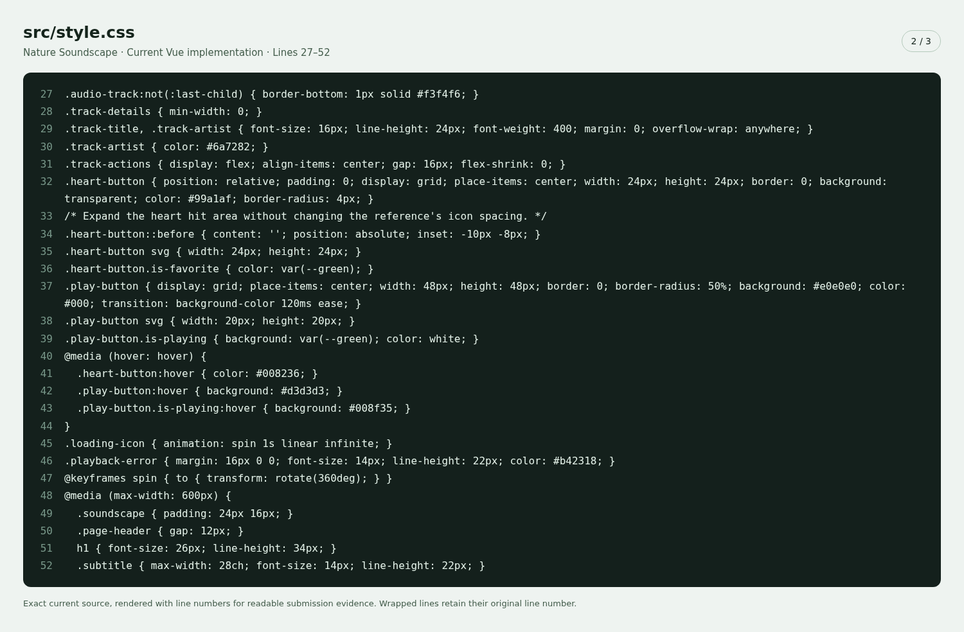
Figure 5. Styling for control sizes, active states, and smaller screens.
I checked the playback interaction by comparing the interface before and after selecting Play. In the default screen, all playback buttons are gray and display a play icon. After selecting “Sounds of the Forest,” its button displays a white pause icon on a green background, while the other controls remain in their default state. This comparison provides evidence that the selected track’s visual state updates without changing the rest of the list. It supports the interface behavior, although a screenshot alone cannot confirm audible playback.
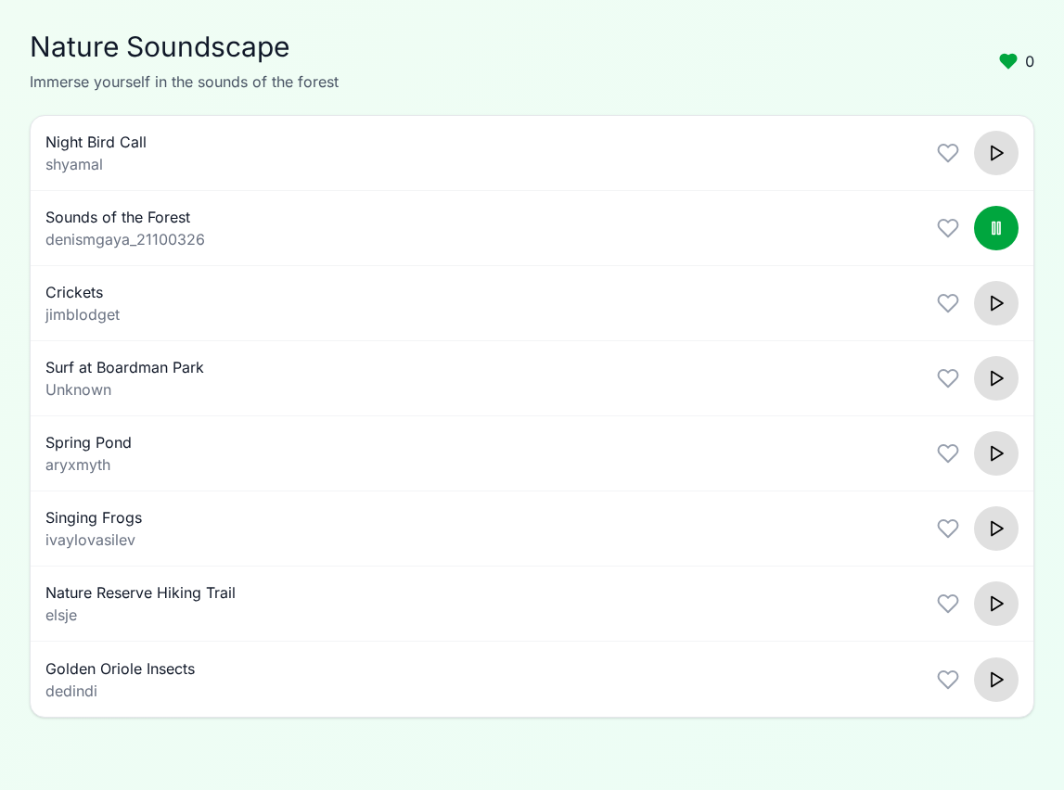
Figure 6. Selected track displaying the active pause control.
I also checked favorite removal by comparing the screens with two favorites and one favorite. Before removal, “Sounds of the Forest” and “Crickets” have filled green hearts, and the header shows two favorites. After removing “Crickets,” its heart returns to an outline and the counter decreases to one. This helped verify that the individual control and the overall count update together. Comparing these interaction states with the intended design helped me check both the appearance of the application and how it responds to user actions.
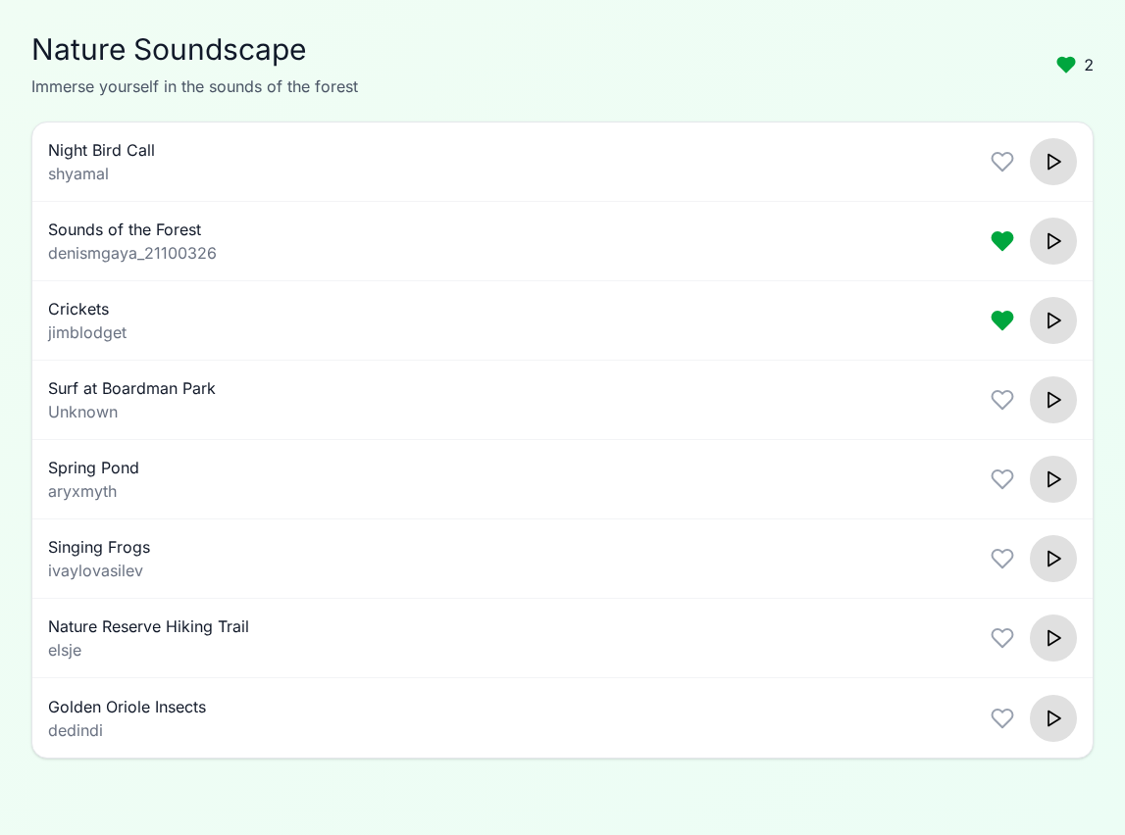
Figure 7. Two selected favorites before removing a track.
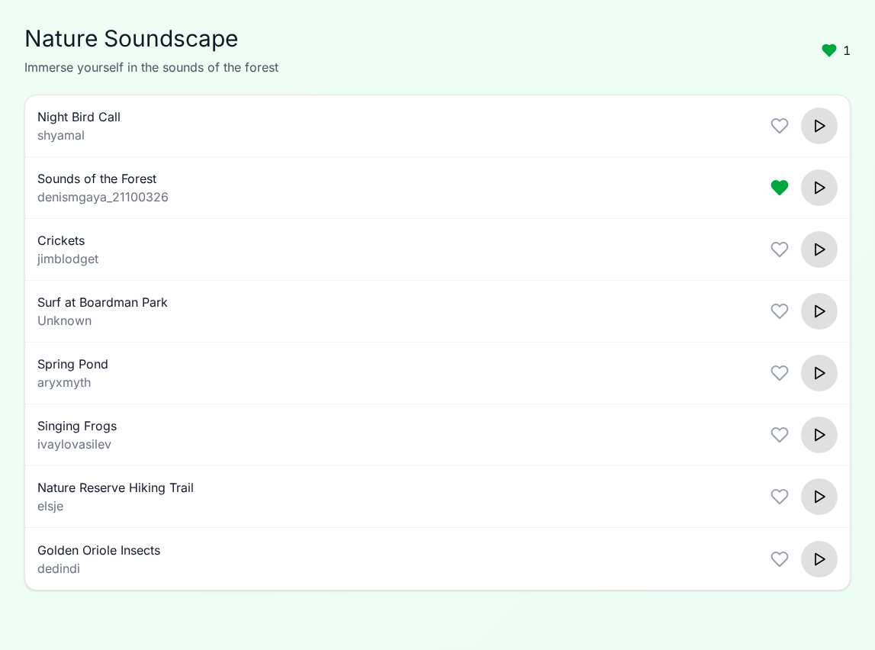
Figure 8. Favorite counter decreasing to one after removing “Crickets.”

